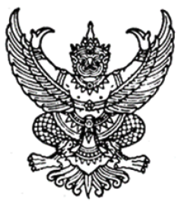

Thammasat University Regulations
on Graduate Education (No. 3) B.E. 2565 (2022)

----------------------------------

Whereas it is expedient to amend the Thammasat University Regulations on Graduate Education B.E. 2561 (2018);
By virtue of the powers conferred by Section 23(2) of the Thammasat University Act B.E. 2558 (2015), the University Council in meeting no. 4/2565 on 25 April B.E. 2565 (2022) issued the following Regulations.

Article 1. These Regulations are called “Thammasat University Regulations on Graduate Education (No. 3) B.E. 2565 (2022)”.

Article 2. These Regulations will apply to students who are registered as students at graduate degree level in academic year 2561 (2018) onwards.

Article 3. The content of Article 62 of the Thammasat University Regulations on Graduate Education B.E. 2561 (2018) will be repealed and replaced with the following:
“Article 62. The production of a thesis, an independent study, and an independent research report will be in accordance with the format that the Rector, on the recommendation of the Thammasat University Library, shall prescribe by making an announcement of the University.
The copyright in the thesis, independent study, or independent research report will be jointly held between the University and the student.
In the event that a student has an agreement relating to research, an agreement for academic collaboration with an organisation or agency, or an agreement with any other person that prescribes otherwise concerning copyright, that agreement will have effect only as regards the copyright of the student.

Announced on 23 May B.E. 2565 (2022)
[Signature]
(Adjunct Professor Noranit Setabutr)
President of the University Council

